Stepper Motor:

Stepper motors were developed in the early 1960's as a low cost alternative to position servo systems in the emerging computer peripheral industry. The main advantage of stepper motors is that they can achieve accurate position control without the requirement for position feedback. In other words, they can run "open-loop", which significantly reduces the cost of a position control system.

Stepper motors utilize a doubly-salient topology, which means they have "teeth" on both the rotor and stator. Torque is generated by alternately magnetizing the stator teeth electrically, and the permanent magnet rotor teeth try to line up with the stator teeth. There are many different configurations of stepper motors, and even more diverse ways to drive them.

The most common stator configuration consists of two coils (A and B). These coils are arranged around the circumference of the stator in such a way that if they are driven with square waves which have a quadrature phase relationship between them, the motor will rotate. To make the motor rotate in the opposite direction, simply reverse the phase relationship between the A and B signals. A transition of either square wave causes the rotor to move by a small amount, or a "STEP". Thus, the name "stepper motor".

The size of this step is dependent on the teeth arrangement of the motor, but a common value is 1.8 degrees, or 200 steps per revolution. Speed control is achieved by simply varying the frequency of the square waves.
Because stepper motors can be driven with square waves, they are easily controlled by inexpensive digital circuitry and do not even require PWM. For this reason, stepper motors have often been inappropriately referred to as "digital motors". However, by utilizing power modulation techniques to change the quadrature square waves into sine and cosine waveforms, even MORE step resolution is possible. This is called "micro-stepping", where each discrete change in the sine and cosine levels constitutes one micro step.

Theoretically, there is no limit to the position resolution achievable with micro-stepping, but in reality, it is limited by the motor mechanical and electrical tolerances. Some stepper motors are designed specifically for micro-stepping, and consist of tightly matched impedances between the A and B coils, and tighter machining tolerances on the teeth, at the expense of higher cost.
Key Characteristics:
- Low cost solution for position control
- Inherent "zero-following" error in servo systems
- Easy to interface to digital controllers
- Inherently high torque/position gain resulting in excellent holding torque
- Limited holding torque available even when the motor is unpowered
- Heat is generated in the stator and is easy to remove
- Synchronous operation permits tight open-loop speed control

STEPPER MOTOR CONTROL
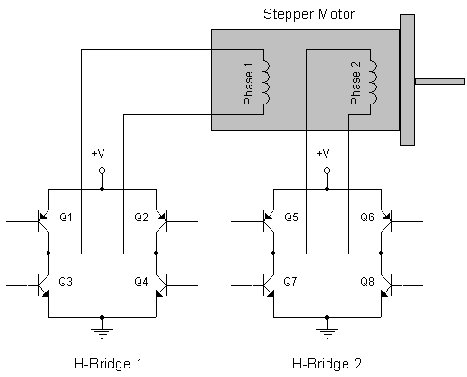

Application Parameters:
Voltage | Motor Power | Speed Range
6 - 24 Vac | several watts | 0 - 1,000 RPM  0 - 10,000 RPM (chopper)

Applications:
- Cruise control
- Auto air vents
- Light leveling
- Printers
- Industrial machines
- Automotive gauges
- Office equipment
- Computer drives
- Medical scanners
- Scientific Instrumentation

